Darkling Beetle
Habitat Enrichment
Presented by Group 9
Brandon Ho, Bryce Dodson, Jadyn Goodson-Pelayo and Pablo Vazquez
8 April 2026

Project Description
Our team was tasked with an environmental enrichment project for the Darkling Beetles at the OKC Zoo. The Zoo was having trouble with their environments not being natural enough and asked us to design a solution. They gave us some constraints that we needed to follow so we wouldn’t harm the bugs. These constraints are to make it seem natural in its regular environment, stay away from wood, use no paint, no kind of sealing product, no kind of stain, and absolutely no chemicals. Currently their environment consists of egg cartons and paper towel rolls. These bugs like to burrow under leaf litter, dogpile on each other, tunneling up and down through spaces, and enjoy the dark spaces of their environment.
Along with some of those constraints, they did have some requirements for us to add to our project. One of these requirements must be easy to clean since they are cleaned out every 24 hours; that means being able to take it apart to ensure cleanliness. Another requirement was to make sure the design has ventilation since the bugs enjoy dark humid environments the staff needs to make sure the temperature of the habitat stays around 68-72 degrees. With ventilation being a requirement, this also helps since the eggs are sticky and stick to walls if they are laid there but also helps maintain a humid environment. Lastly, they asked for it to be as natural looking as we can get it that way they can feel in their natural environment. You might be thinking that big changes like this can be stressful to get used to again, but stress is good for animals as it helps them to constantly learn to adapt to what is around them.

Current and Prior Solutions
Our team went with designing a log with a tunnel system inside as well as a lower layer to lay leaf litter in for the Bettles to lay eggs under or just dogpile on. We went with this design due to the bugs enjoying the paper towel rolls as well as the toilet paper rolls. This allows them a tunnel to crawl through as well as a dark space. In addition to 3D printing a log we hollowed out the inside to allow a bottom layer for leaf litter, and gave them an upper layer to crawl around and get into tighter places to pile in. Since we hollowed out the inside from end to end it allows for a lot of ventilation and allows the bugs to come and go as they please. To make this design easy for the staff to clean, we made it into two parts that slide together so when it comes time to clean it, they can get into it thoroughly and make sure it’s clean for the next day. Attached below is currently what the zoo is using for these beetles in their habitat.
The biggest reason we went with this design is because it being very easy to clean as well as being as natural as we could get it. We had looked at other designs, but they failed the initial test if they were the right fit. Looking at what The Zoo is currently using is cheap but not in a bad way since they are using everyday materials for another use. Our design costs around $5-$10 in materials in addition to a 3D printer which they have at their disposal. This helps so if they wanted to implement it in other habitats, they could easily print some more and add them.
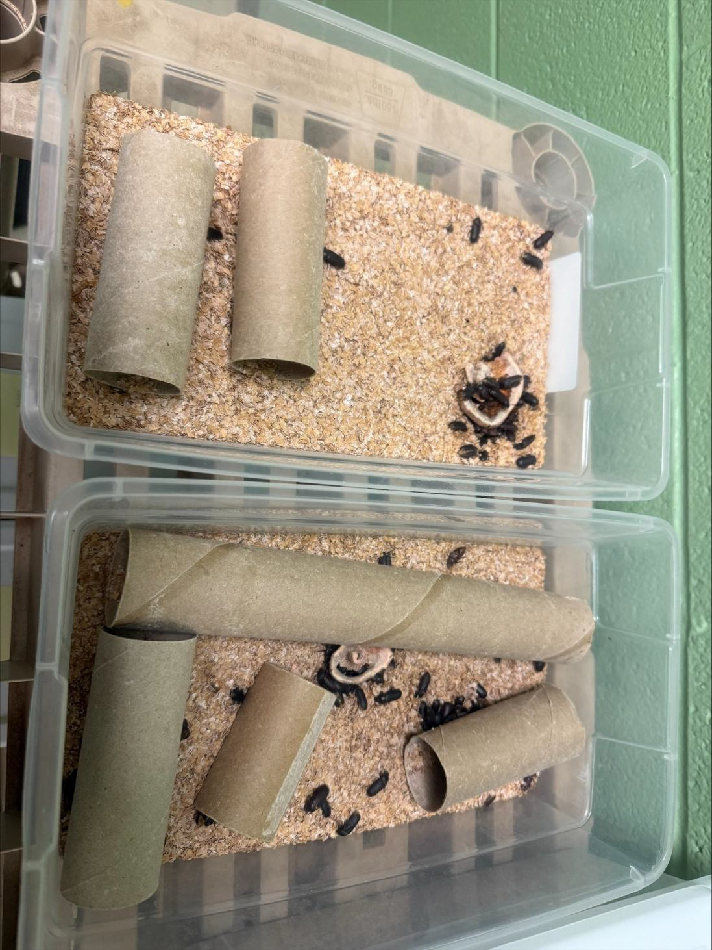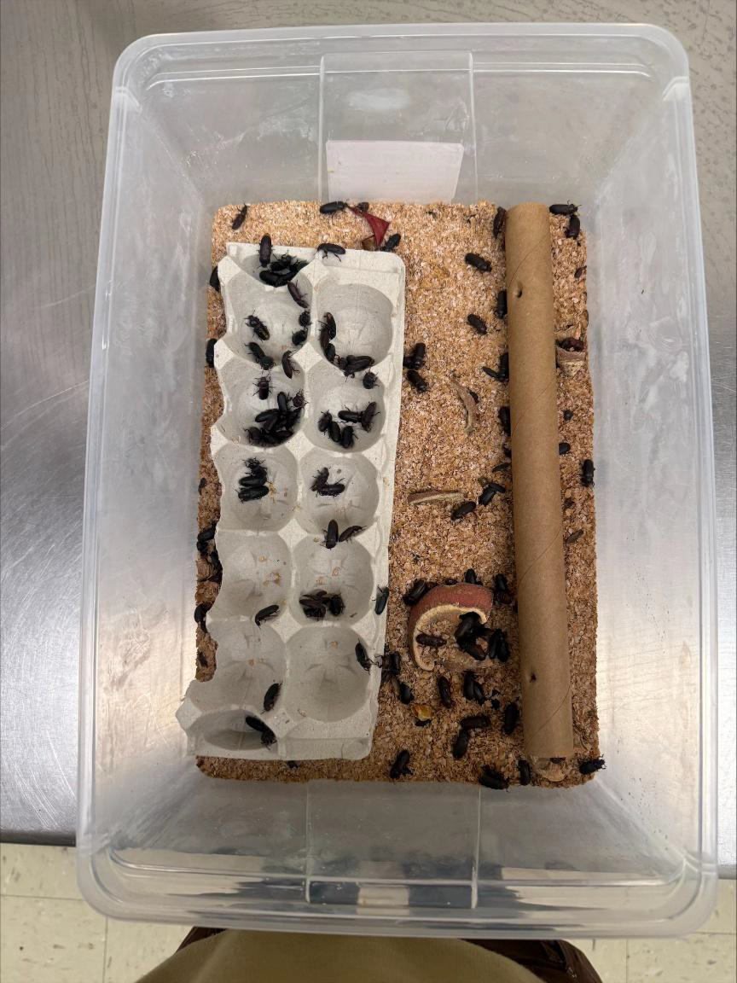
Figure 1: Current habitat setups at the OKC Zoo showing the small bins (left) and large bin (right) using cardboard tubes and egg cartons as enrichment.

Ideation:
Each member of our team brainstormed three potential designs a piece. The designs ranged from intricate hotels and mazes to something as simple as a log and egg carton. Below are pictures of said designs along with descriptions.
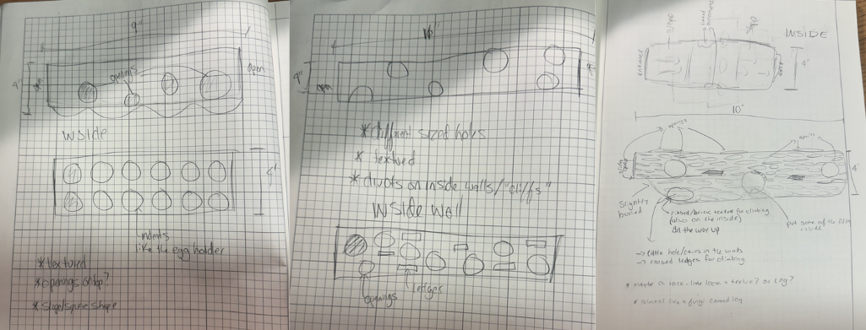 Figure 2: Initial ideation sketches showing three concept designs: an egg-carton-style enclosure (left), a box-wall design (center), and a log-inspired hide (right).
The left design is similar to an egg carton. It is a rectangular space with divots on the floor, similar to an egg holder. The walls have various sizes of holes for the beetles to crawl through as well. The middle design is very similar, but without the divots on the floor. Instead, it has caves in the wall at different elevations for the beetles to crawl around to. The final design on the right is modeled after a log. Half of the design is made to be on the ground, so the beetles can feel as if they are burrowing. The top slides off for easy cleaning. There are many holes for ventilation and for climbing through. The inside walls also have many small caves and openings, so the beetles have dark areas to climb to.
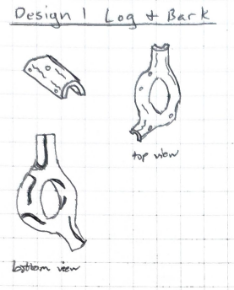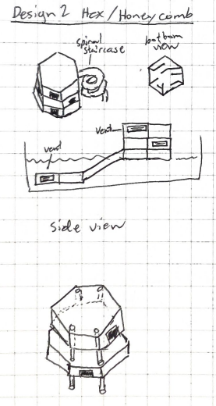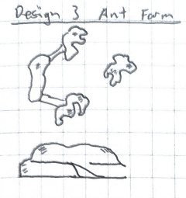
Figure 3: Sketches of the Log and Bark (left), Hex/Honeycomb (center), and Ant Farm (right) design concepts developed during ideation.
The Log and Bark design consisted of a 3D-printed half-log shape with internal tunnels and vent holes for airflow. The log would not be a full tube but instead split into a top and bottom piece for easier cleaning. The natural log shape was intended to blend into the habitat and give the beetles a familiar form to explore. The Hex/Honeycomb design used modular hexagonal compartments that could be stacked and connected using clips or poles. This design featured a spiral staircase element inside for elevation, ventilation slits along the sides, and compartments that could be partially buried to create tunnel ramps. The modular nature meant it would not be fully enclosed, making cleaning more accessible. The Ant Farm design featured hollow rock-shaped objects with multiple internal layers. This design would provide different levels for the beetles to climb between and included vents for airflow, but its more complex geometry would be more difficult to manufacture and take apart for cleaning.
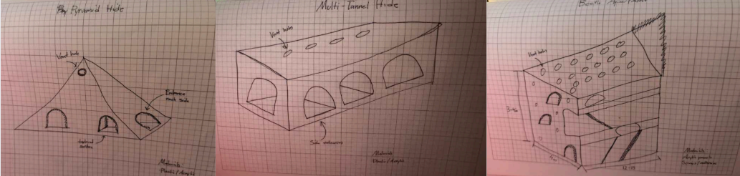 Figure 4: Sketches of three additional enclosure concepts exploring pyramid, box with arch entrances, and slanted-surface forms.
The sketches show three different ideas for an enclosure design. The first sketch looks like a pyramid with small openings along the sides, which allow the beetles to move in and out. It also serves as air flow. The second design is more like a box shape and includes multiple arch like entrances on the sides, suggesting easier access and a more stable structure. The third design appears more complex, with slanted surfaces and multiple holes across the top, for ventilation and movement between the levels. Overall, these designs explore different shapes and layouts, focusing on how the beetles would move through the space, how air would flow, and how the structure would be built.
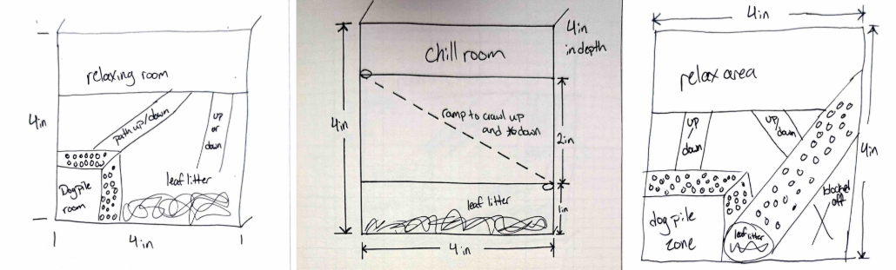 Figure 5: Sketches of three box-based, two-level enclosure concepts showing different combinations of leaf litter areas, dog-pile spaces, and elevation ramps.
Starting from left to right:
All these designs were made to resemble a box. The first one was designed with two layers; the first layer consisted of leaf litter for them to lay eggs in and get under as well as a box with holes all over for them to crawl in and out of if they wanted to dogpile in.Then on top of the box is a ramp leading to the second layer if they wanted a cooler environment and a ramp from the second layer down to the bottom. The second design is like the first but doesn't have the box for them to dogpile in. It does contain 2 layers with the bottom layer containing purely leaf litter with a ramp to the top for them to be in a cooler environment. Lastly, the third design is most like the first design. It contains the box for them to dog pile in as well as the rams to get from the bottom layer to the top. Also included is a tube that would be designed like a log filled with leaf litter and would act as a ramp to get to and from the top and bottom layers.
The design criteria we decided was best for our project consists of cleanable, complexity, size/space, natural look, and elevation. Cleanable refers to the ability for the design to be taken apart and cleaned. Complexity describes the intricateness of the design. Size/space refers to the measurements of the design along with how much space the beetles have. Natural look refers to how natural the design looks if it were in the beetles’ natural habitat. Elevation refers to if the design has different levels of elevation for the beetles to explore. We chose these as our design criteria because we felt they fit the requirements and constraints the best while also letting us be creative with our enrichment design. The design criteria weight chart went as follows:

 | Cleanable | Complexity | Size/Space | Natural Look | Elevation | Row Total | Weight
Cleanable | X | 1 | 0 | 1 | 1 | 3 | 30%
Complexity | 0 | X | 0 | 0 | 0 | 0 | 0%
Size/Space | 1 | 1 | X | 1 | 1 | 4 | 40%
Natural Look | 0 | 1 | 0 | X | 1 | 2 | 20%
Elevation | 0 | 1 | 0 | 0 | X | 1 | 10%
 |  |  |  |  | Total: | 10 | 100%

Due to the criteria of complexity not being as important as we thought, we ended up removing it from the final decision matrix. Our top 4 designs were the honeycomb, ant farm, the fake log, and the hotel. The decision matrix went as follows:
 |  | Honeycomb |  | Ant Farm |  | Fake Log |  | Hotel
Design Criteria | Weight | Weighted Score | Rating | Weighted Score | Rating | Weighted Score | Rating | Weighted Score | Rating
Size | 40% | 3 | 1.2 | 4 | 1.6 | 4 | 1.6 | 5 | 2
Cleanable | 30% | 1 | 0.3 | 1 | 0.3 | 5 | 1.5 | 2 | 0.6
Natural Look | 20% | 1 | 0.2 | 3 | 0.6 | 5 | 1 | 1 | 0.2
Elevation | 10% | 5 | 0.5 | 2 | 0.2 | 4 | 0.4 | 5 | 0.5
Total Score |  | 2.2 |  | 2.7 |  | 4.5 |  | 3.3
Ranked |  | 4 |  | 3 |  | 1 |  | 2

By making our design criteria weighted and ranking each of our top 4 designs by each design criteria, we came up with our final design as the fake log. We chose this design because we felt it was the most natural looking, had the easiest cleaning, and was simple yet complex enough for the beetles to have plenty of areas to go.

DESIGN
The selected Fake Log design was modeled in Fusion 360 and consists of two interlocking pieces: a bottom tray and a top shell. The bottom piece is a half-cylinder tray that holds leaf litter and substrate for the beetles to burrow in. It measures 8 inches long, 4 inches in outer diameter, and approximately 1.25 inches tall. The top piece is a matching half-cylinder shell that slides onto the bottom tray using a rail-and-groove connection. The interior of the top piece contains curved walls that create multiple dark chambers, giving the beetles separate hiding spots for breeding, egg laying, and stress reduction. Along the right side of the top piece are ventilation slits that allow airflow through the structure to prevent the deadly dog-piling behavior that can occur in poorly ventilated hides. The top piece also features multiple entrances and exits along the sides, which is critical since darkling beetles cannot reverse easily and need a way to pass through without turning around. The overall log shape and brown PLA filament give the hide a natural appearance. When assembled, approximately 1.5 inches of the hide is intended to be buried in the substrate, leaving about 2.5 inches of usable height above ground.

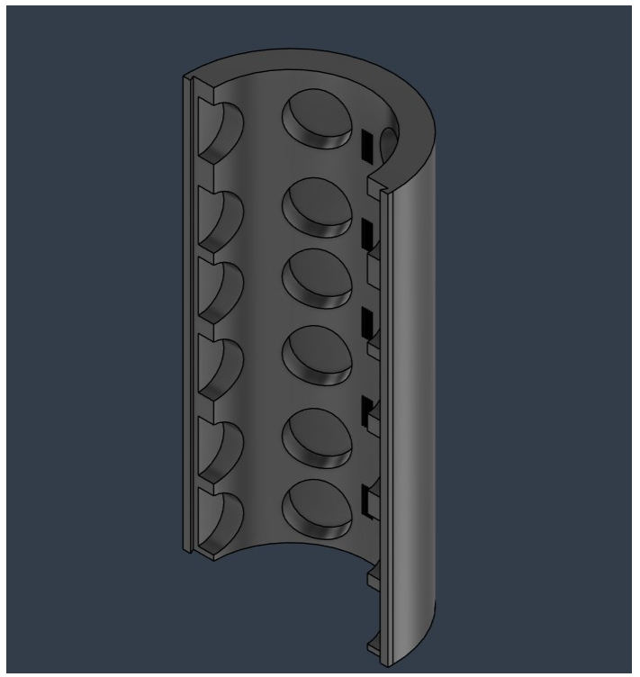
Figure 6: CAD render of the top shell modeled in Fusion 360, showing the internal wall chambers, ventilation slits, and hiding holes.
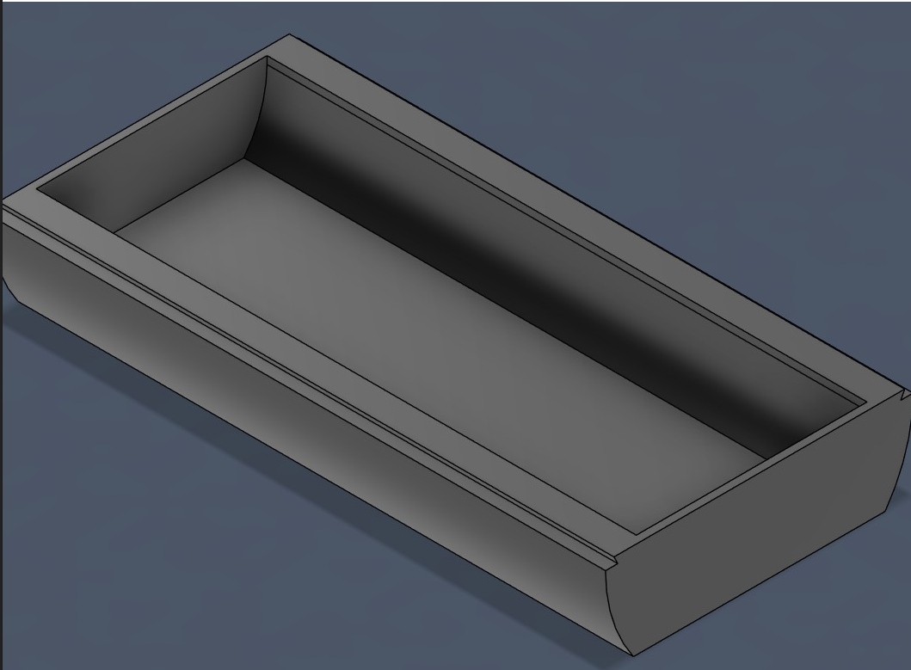
Figure 7: CAD render of the bottom tray modeled in Fusion 360, showing the half-cylinder shape and rail connection edges.
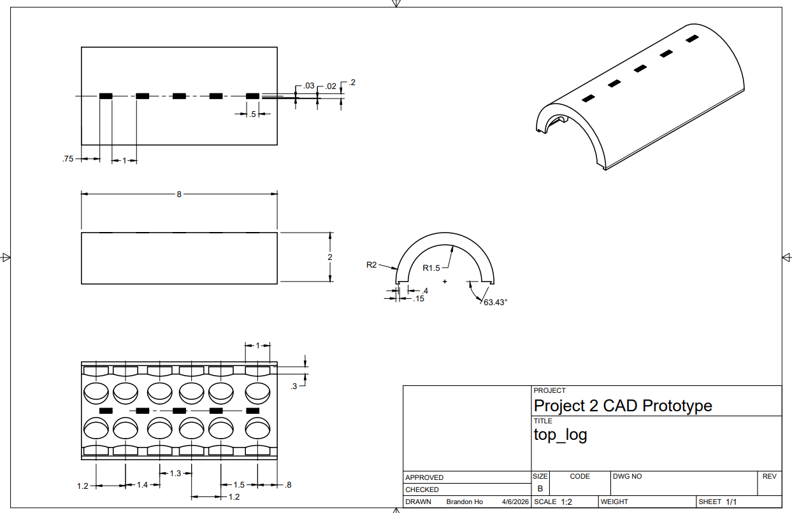
Figure 8: Engineering drawing of the top log piece with dimensions, showing internal wall spacing and ventilation slit placement.
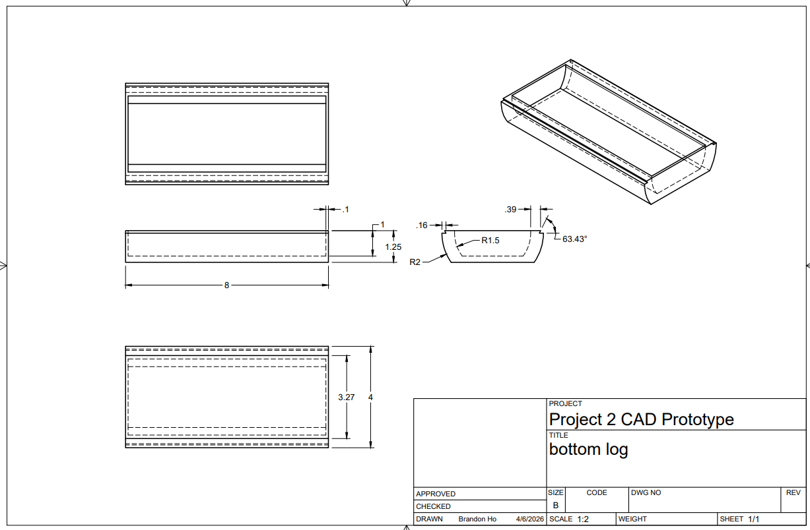
Figure 9: Engineering drawing of the bottom log piece with dimensions, drawn in Fusion 360.
The team first built a rapid prototype in class using cardboard and tape to visualize the design at scale and verify that the dimensions would fit within the habitat bins. This helped the team confirm the overall form factor and identify that the exact tunnel dimensions and a connection mechanism to hold the top and bottom pieces together would need to be refined in CAD before printing. After making those refinements in Fusion 360, the team 3D printed a proof-of-concept prototype on a Bambu Lab printer using brown PLA filament. This printed prototype was used to verify the fitment of the slide-together connection and served as the first testable prototype for the testing plan described in the following section.
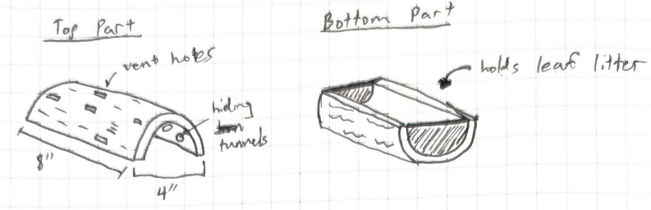
Figure 10: Rapid prototype sketch from the engineering notebook showing the top and bottom pieces with labeled features including vent holes, hiding tunnels, and leaf litter tray.

PROTOTYPE AND TESTING
The first testable prototype was 3D printed using a Bambu Lab printer in a brown PLA filament to resemble a natural log. The design consists of two interlocking pieces: a bottom tray that holds leaf litter and substrate, and a top piece that features internal curved walls creating multiple dark chambers for the beetles to hide in. The top piece also includes ventilation slits near the top and multiple entrances and exits along the sides, since darkling beetles do not reverse well and need a way to move through the structure without turning around. The overall shape is a half-cylinder log form, measuring 8 inches in length and 4 inches in outer diameter. In practice, approximately 1.5 inches of the hide would be buried in the substrate, leaving about 2.5 inches of usable height above ground for the beetles to climb and take advantage of elevation for temperature control. This single size was designed to fit within both the small bins (12" × 6") and the large bins (18" × 12") used at the OKC Zoo. The two pieces slide together and apart without the need for any hardware, making the hide easy to assemble, disassemble, and clean. Figure 11 shows the two pieces separated, and Figure 12 shows the assembled prototype.
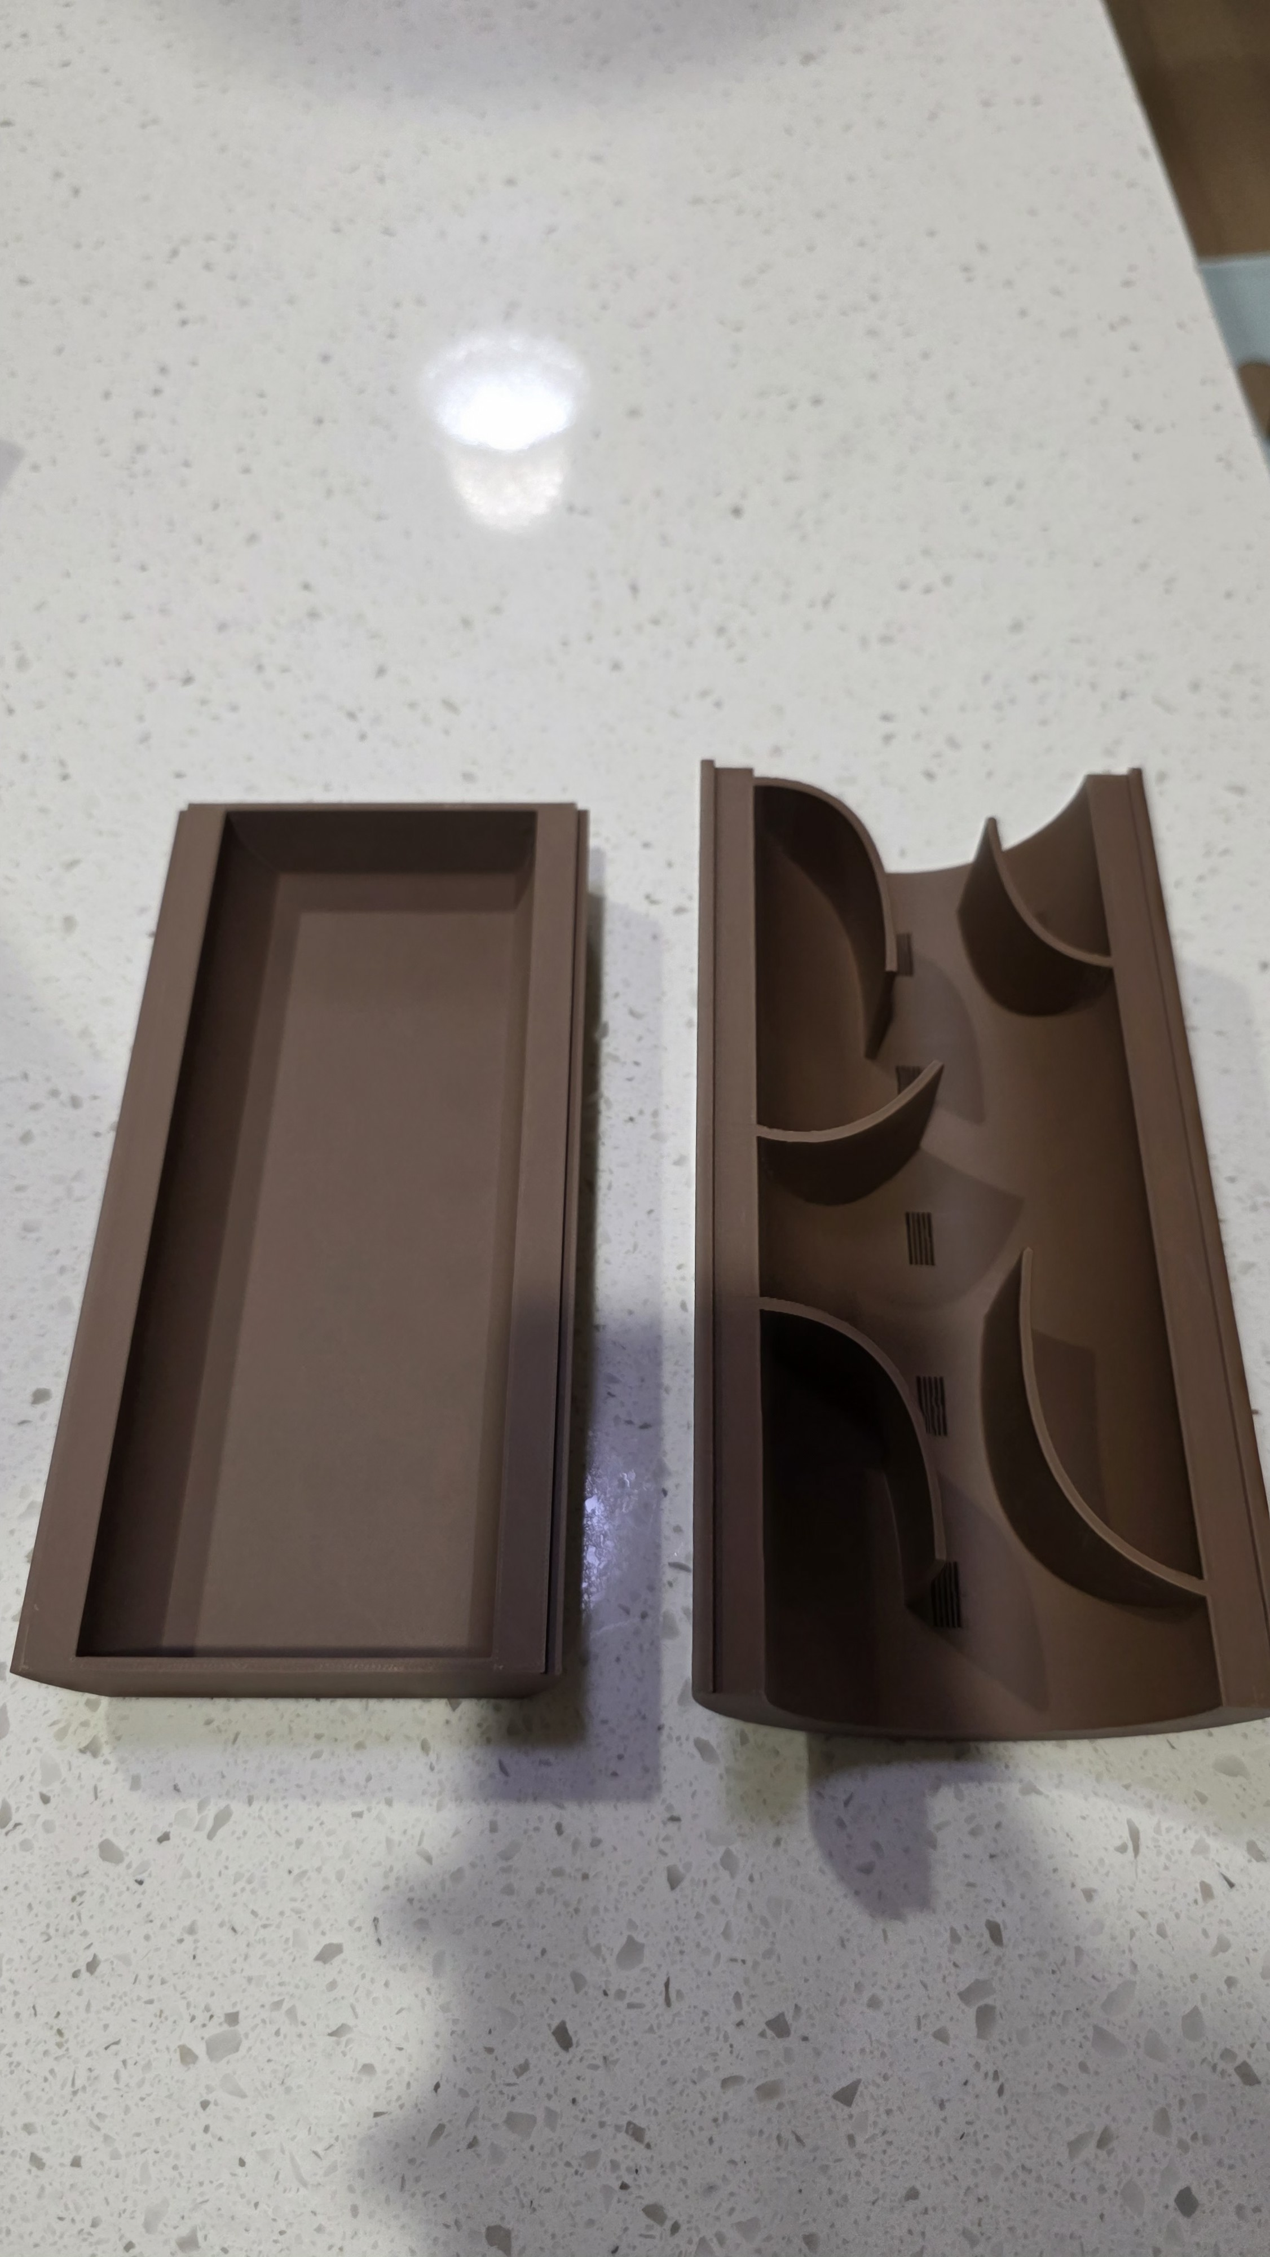
Figure 11: The top and bottom pieces of the 3D printed prototype shown separated, displaying the internal wall structure of the top piece and the open tray of the bottom piece.
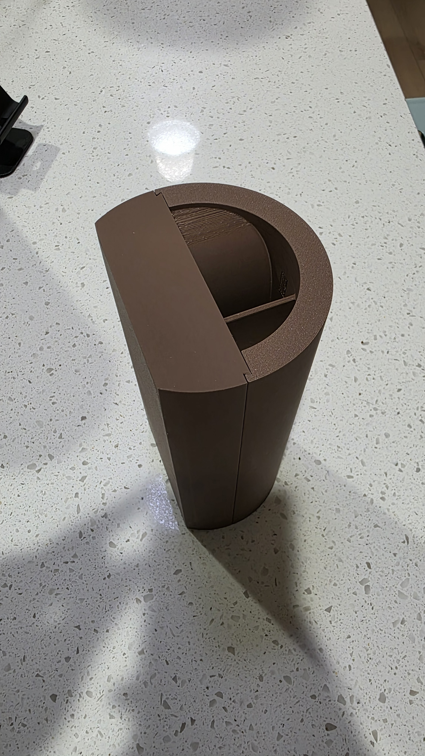
Figure 12: The fully assembled prototype standing upright, showing the log-like exterior shape and the seam where the two halves connect.

To evaluate whether the prototype met the project requirements and constraints, the team developed a testing plan covering six key areas: size, cleanability, surface texture, elevation, ventilation, and structural strength. Each test was designed so that a person outside the team could replicate the procedure and verify the results. The testing plan and results for the rapid prototype are summarized in Table 1.

Table 1: Testing plan results for the initial 3D-printed prototype, showing pass/fail status for each requirement and constraint.
Requirement/Constraint | Testing Plan | Passing Description | Prototype Result
Size (max length 10", max diameter 4") | Measure length and diameter with a ruler | Length ≤ 10" and diameter ≤ 4" | Pass — 8" long, 4" diameter
Cleanable (take apart) | Use different connection types and tolerances; printing and testing fitment | Top and bottom pieces can be put together and taken apart | Pass — Pieces slide together and apart easily
Surface Texture | Place bugs found outside on the design and observe | Bugs are able to climb the design | Fail — Bugs slid off the smooth printed surface
Elevation (different angle slopes) | Place bugs found outside on the design and observe climbing | Bugs are able to climb the design | Fail — Bugs could not grip the sides to change elevation
Ventilation | Close major holes with tape; use dry ice fog inside | Visible smoke coming out of vent holes | Pass — Smoke was visible exiting the top vent slits
Strength/Sturdiness | Drop test | Does not break | Pass — Prototype survived the drop test without breaking
The prototype passed four of the six tests. The size was within the required limits, the two-piece design was very easy to take apart and reassemble, the ventilation slits successfully allowed airflow through the structure, and the drop test confirmed the print was structurally sound. However, the prototype failed both surface texture and elevation tests. When real bugs collected from outside were placed on the prototype, they were unable to grip the smooth 3D-printed surface and slid off the sides. This meant the beetles could not climb the exterior of the hide to reach the top or take advantage of different elevations, which was one of the client’s key behavioral enrichment goals. This failure identified the surface texture as the most critical issue to address before the final design.

CLIENT FEEDBACK
After the prototype was presented, the client provided several requests for modifications. While only the top piece had been printed with the fuzzy skin texture, the client asked that the bottom piece also receive a textured surface so that beetles could grip and climb both halves of the hide. The client also noted that the wall thickness of the prototype was greater than necessary and asked that it be reduced in order to lower material costs and print time without sacrificing structural integrity. In addition, the client reported difficulty reassembling the two pieces quickly when managing multiple bins at once and asked for a simpler, faster connection method. Finally, the client requested that ventilation slits be added to the bottom piece as well, to ensure that beetles burrowed beneath the tray would still receive adequate airflow.
To address this feedback, the team made four targeted changes in Fusion 360 before reprinting. First, the wall thickness of both pieces was reduced to decrease material usage and shorten print time while maintaining structural soundness. Second, the connection mechanism was redesigned by adding a flat square alignment guide at the first half inch of the sliding joint, allowing the two pieces to seat quickly and correctly—an especially important improvement given that the client manages many bins each day. Third, ventilation slits were added to the bottom piece to provide airflow for beetles that had burrowed into the substrate. Finally, once all design changes were made in Fusion 360, both pieces were reprinted using the fuzzy skin setting so that beetles could grip and climb the surface of each half. Each of these changes was incorporated into the final design described in the following section.

FINAL DESIGN
To go from the prototype to the final design, the team focused on solving the surface texture problem that caused both test failures. First, as a proof of concept, the team sanded the outer surface of the rapid prototype by hand to create a rougher texture. When bugs were placed on the sanded surface, they were able to grip and climb successfully, confirming that adding texture to the exterior was the correct solution. However, hand sanding was not a consistent or repeatable manufacturing method, so the team turned to a software-based approach for the final print. Using Bambu Lab Studio’s “fuzzy skin” setting, the team reprinted the prototype with an automatically generated rough texture across the entire outer surface. This setting introduces small random variations to the outer wall during printing, creating a fine, slightly fuzzy texture that gives the beetles’ feet enough grip to climb without any post-processing work. No other changes to the geometry, dimensions, or internal structure of the design were needed, as all other aspects of the prototype had already passed testing.
In addition to the texture fix identified through testing, the team incorporated all four pieces of client feedback into the final design before printing. The wall thickness of both pieces was reduced to lower material usage and print time while maintaining structural strength. An alignment guide was added to the first half inch of the sliding joint so that the two halves seated together quickly and intuitively without requiring the user to search for the correct orientation—an important improvement for staff managing multiple bins throughout the day. Ventilation slits were added to the bottom piece so that beetles burrowed beneath the tray would receive sufficient airflow. Finally, both the top and the bottom pieces were reprinted using the fuzzy skin setting, rather than the top piece alone, ensuring that beetles could climb either surface of the hide. Together, these revisions addressed every concern raised by the client and resulted in a more functional, efficient, and user-friendly final product.
The final design was then retested using the same testing plan applied to the initial prototype. All six tests passed on the final version. The dimensions remained at 8 inches long and 4 inches in diameter, staying within the size constraints. The two-piece slide-together connection still allowed for easy assembly and disassembly, and the design cleaned easily with just water. The ventilation slits continued to allow airflow, confirmed again with the dry ice fog test. The drop test was repeated and the final print held together without damage. Most importantly, the fuzzy skin texture resolved the surface texture and elevation failures — when real bugs were placed on the final design, they were able to grip the exterior surface and climb to different heights on the structure. The final testing results are presented in Table 2.

Table 2: Testing plan results for the final design with fuzzy skin texture applied, showing all requirements and constraints passing.
Requirement/Constraint | Testing Plan | Passing Description | Final Design Result
Size (max length 10", max diameter 4") | Measure length and diameter with a ruler | Length ≤ 10" and diameter ≤ 4" | Pass
Cleanable (take apart) | Test fitment of connection; wash with water | Top and bottom pieces can be put together and taken apart easily | Pass
Surface Texture | Place bugs on the design and observe | Bugs are able to climb the design | Pass
Elevation (different angle slopes) | Place bugs on the design and observe climbing | Bugs are able to climb the design | Pass
Ventilation | Close major holes with tape; use dry ice fog inside | Visible smoke coming out of vent holes | Pass
Strength/Sturdiness | Drop test | Does not break | Pass
The final design successfully addresses the original problem statement provided by the Oklahoma City Zoo. The zoo's caretakers needed enrichment hides for their darkling beetles and mealworms that would provide dark hiding spots for breeding and stress reduction, offer complexity and multiple entrances and exits, allow for elevation changes for temperature control, include ventilation to prevent deadly dog-piling, be made from a durable and subitizable material, and fit within the existing small and large habitat bins. The current cardboard tubes and egg cartons used by the zoo cannot be sanitized, lack structural complexity, and depend on inconsistent donations. The team's 3D-printed log hide meets all of these needs. It is made from sturdy PLA plastic that can be washed and reused rather than thrown away, features internal walls that create multiple dark chambers with several entrances and exits, includes ventilation slits to allow airflow, and can be partially buried to provide both above-ground and below-ground hiding options. The log shape gives it a natural appearance that blends into the habitat, and the fuzzy skin texture allows the beetles to climb the exterior for elevation-based temperature regulation. The only failure encountered during the entire project was the smooth surface on the initial prototype, which was fully resolved in the final design through the fuzzy skin print setting. Overall, the final design passed all six requirements and constraints established in the testing plan and is ready to be presented to the client.

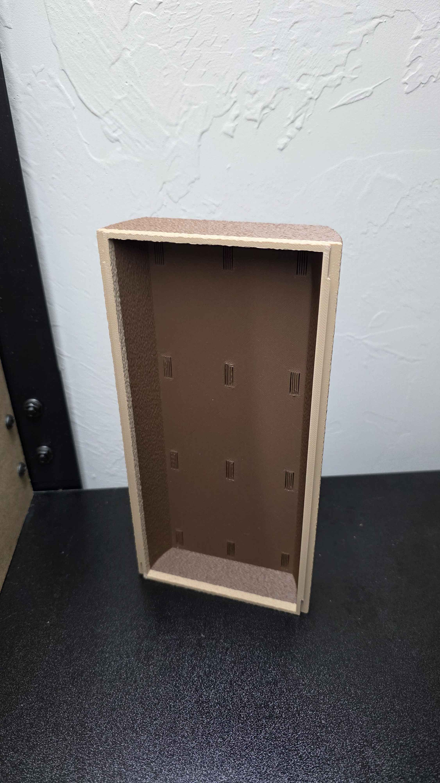
Figure 13: The final prototype bottom tray shown end-on, displaying the ventilation slits on the interior floor and the fuzzy skin texture applied to the outer walls.

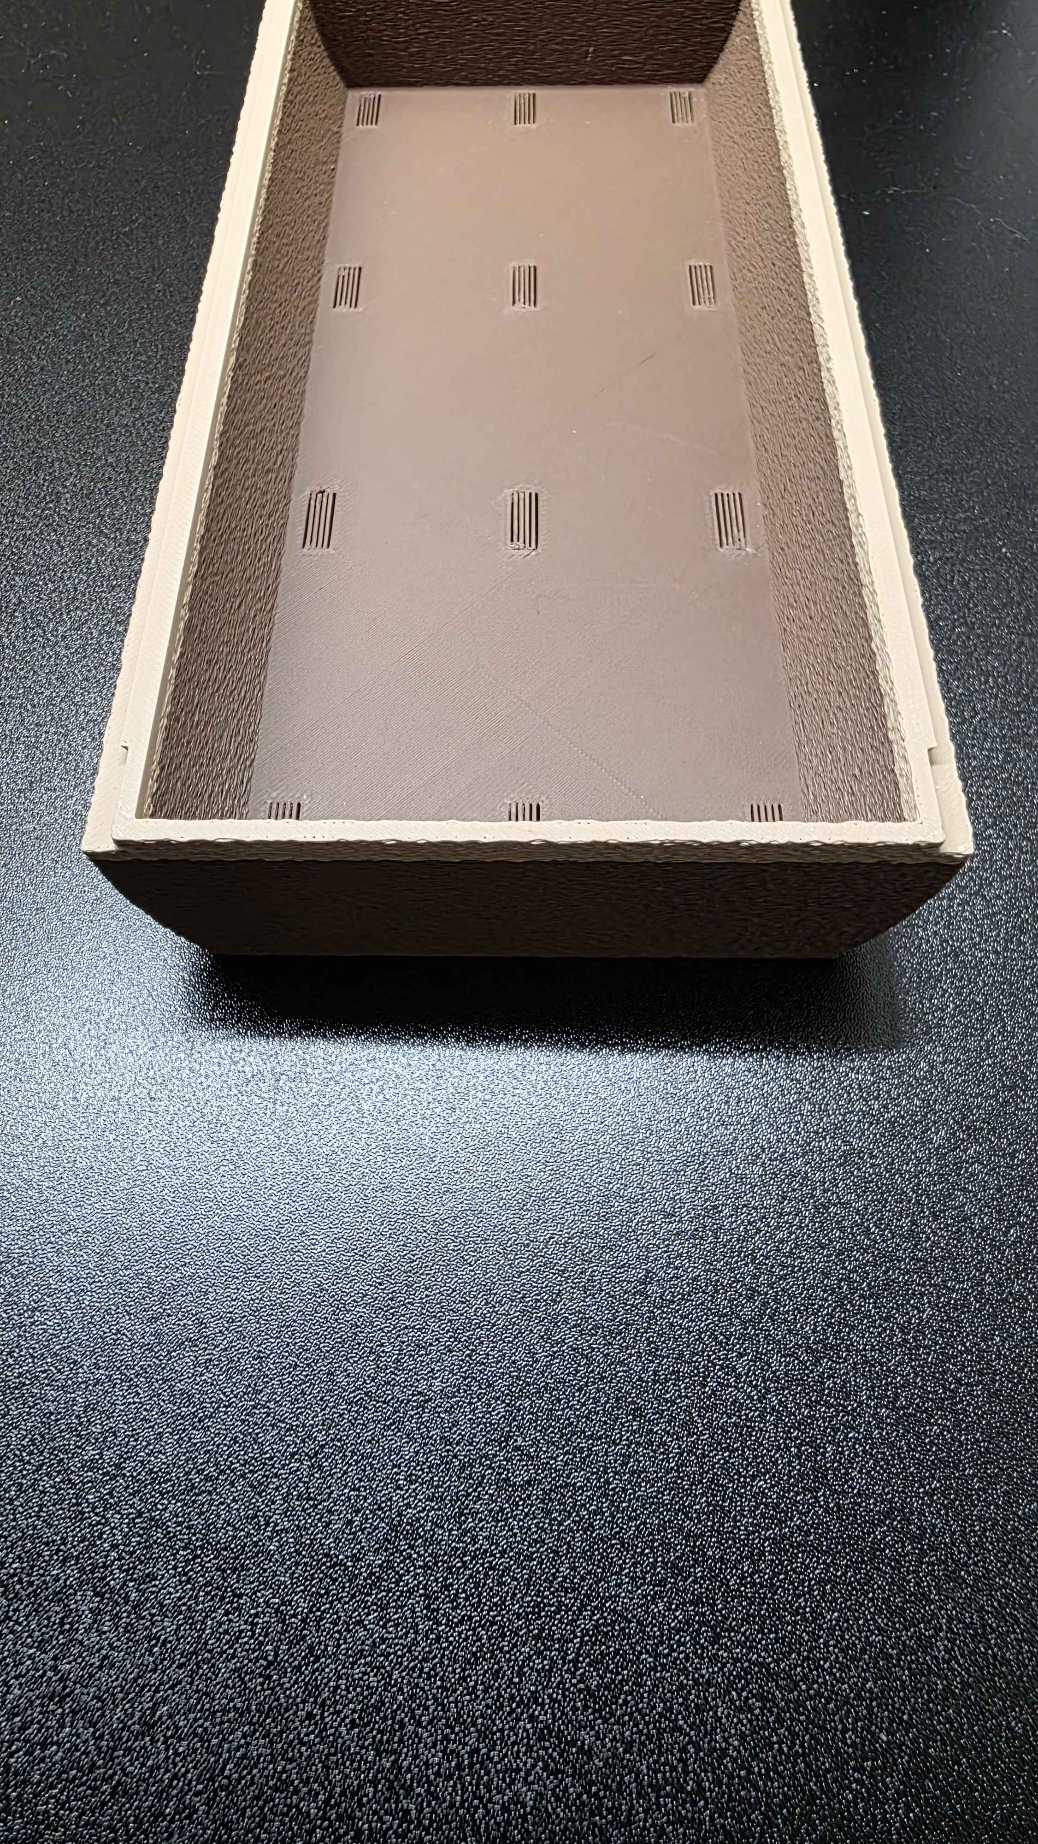
Figure 14: Top-down view of the final prototype bottom tray, showing the ventilation slits cut into the base and the alignment rail along the edges for the sliding connection.
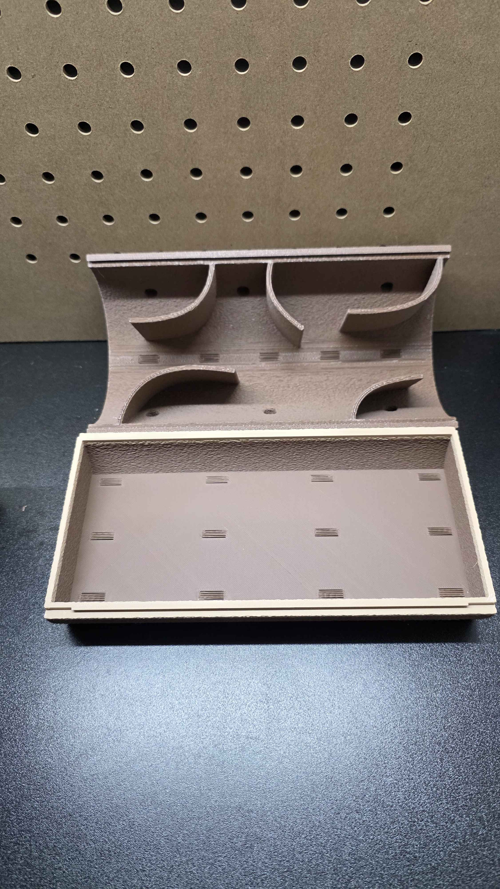
Figure 15: The final prototype with the top shell and bottom tray separated, showing the internal curved wall chambers of the top piece and the open leaf litter tray of the bottom piece.
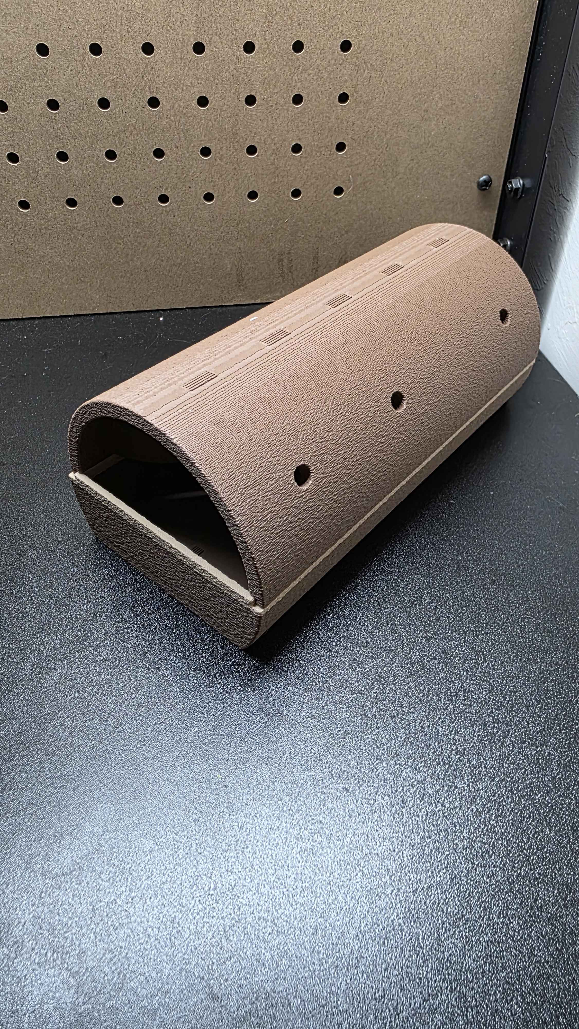
Figure 16: The fully assembled final prototype showing the log-like exterior, fuzzy skin texture, and beetle entrance holes along the side.

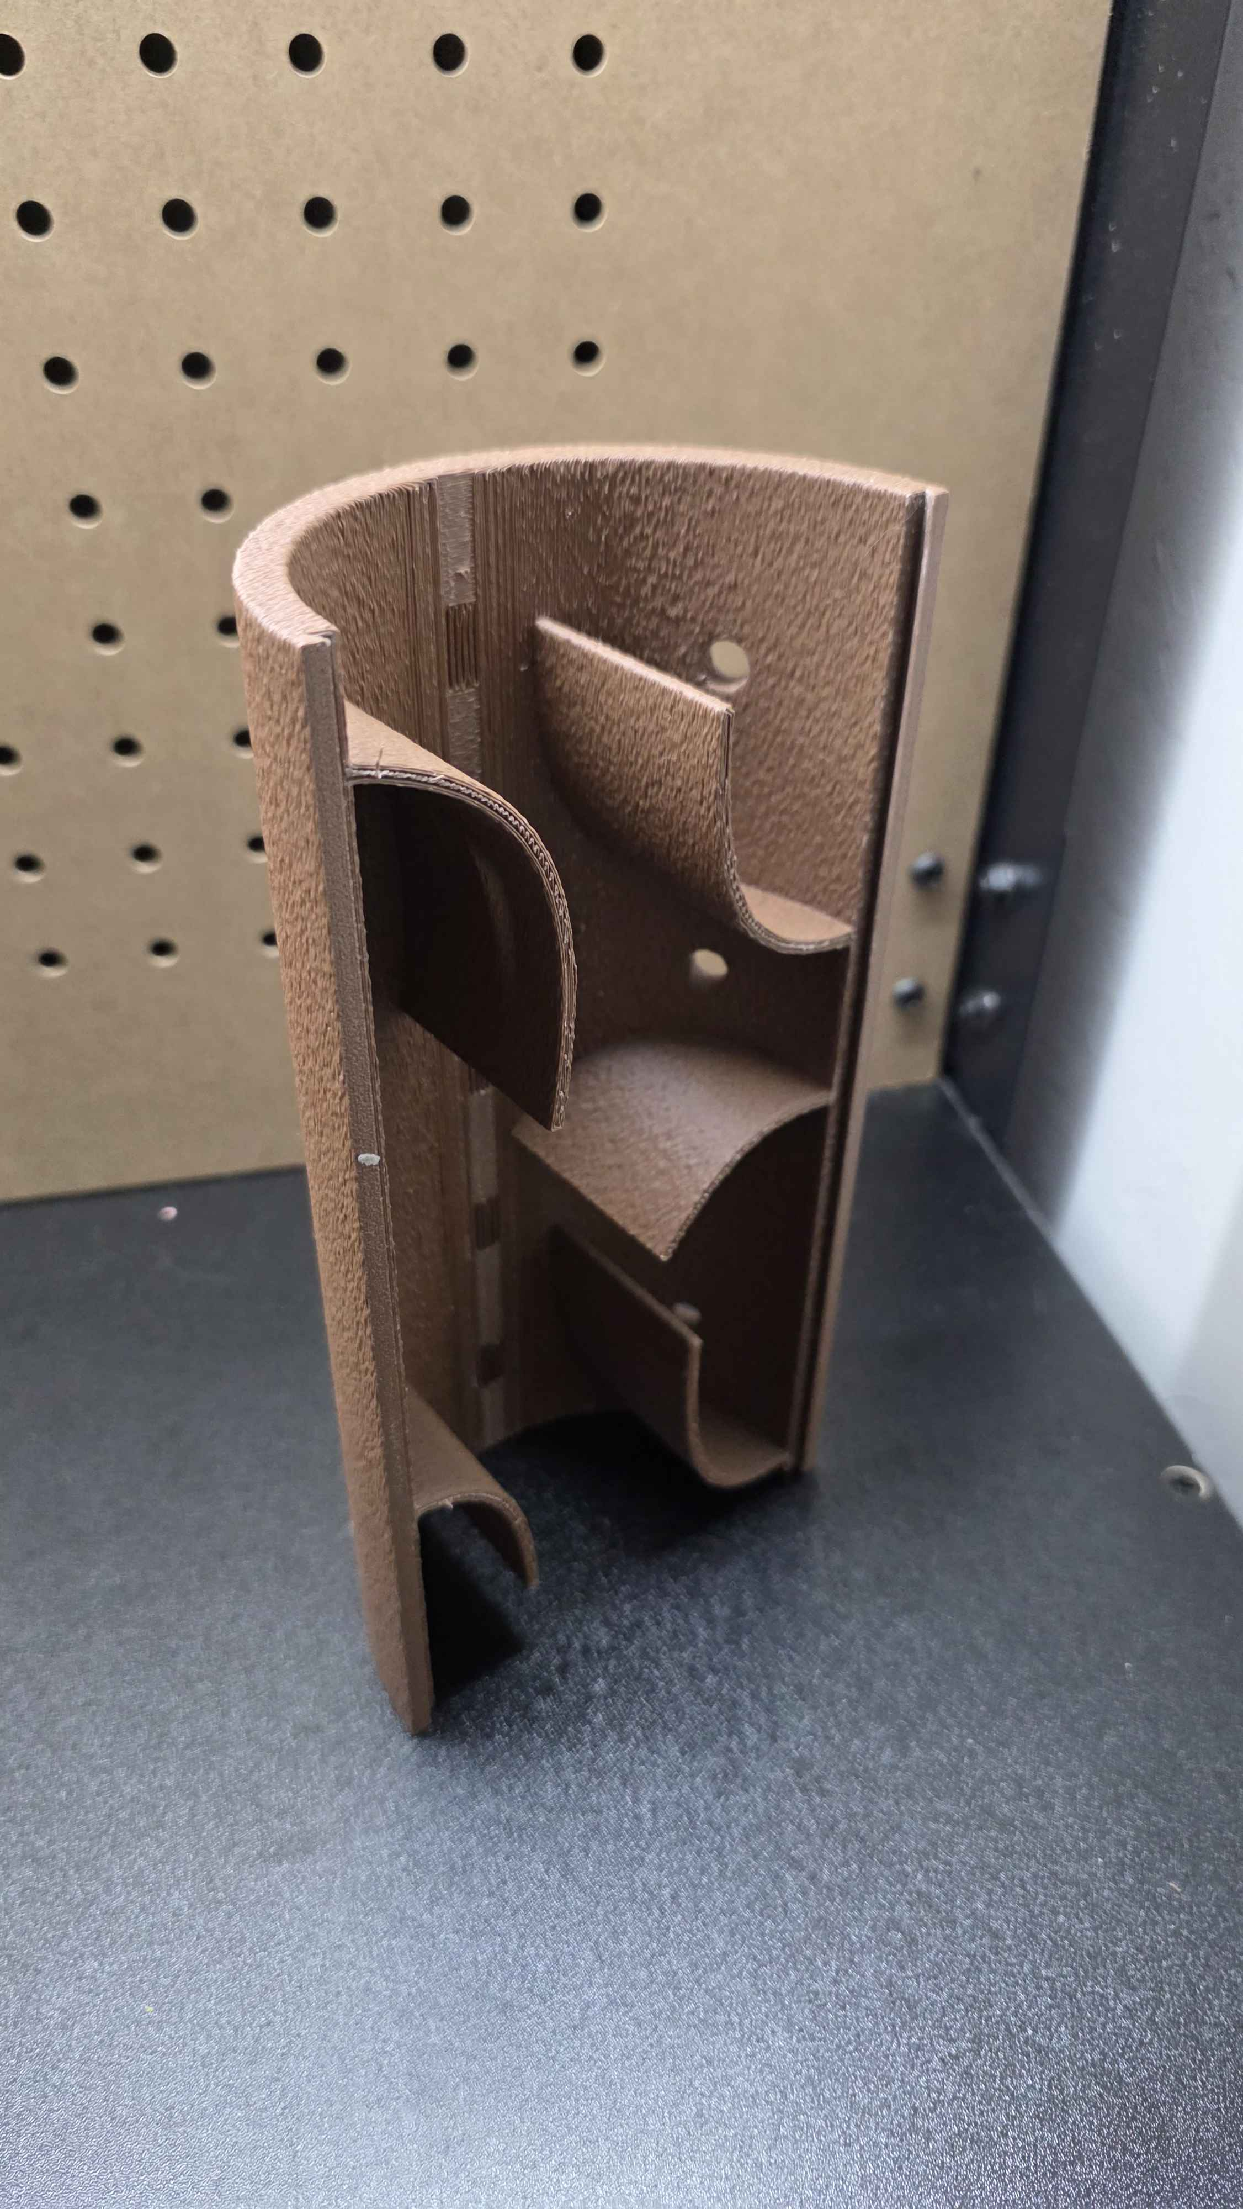
Figure 17: The final prototype top shell shown end-on, revealing the internal curved walls that create multiple dark chambers and the beetle entry holes at different elevations.

Conclusion:
Looking back at our design process, one thing we could have done better is paying more attention to the surface texture earlier instead of mostly focusing on the shape and overall design. Our fake log design worked well for things like ventilation, size, and being easy to clean, but we didn’t really think about how the beetles would move on it. During testing, we saw that the smooth surface made it hard for them to grip and they would just slide off, which caused it to fail the surface texture and elevation tests. If we had tested that earlier or thought more about how insects interact with surfaces, we could have added texture from the start instead of having to fix it later.
If we had more time to improve the design, we would try different textures to see what works best for the beetles to climb and move around comfortably. The fuzzy skin setting fixed the problem, but we could experiment more with it to make it even better. We could also make slight changes to the inside of the log, like adjusting the tunnels or spaces so it better matches how the beetles like to burrow and group together, while keeping it easy to take apart and clean. Overall, the design turned out successful, but with another version, we could make it feel even more natural and useful for the beetles.

